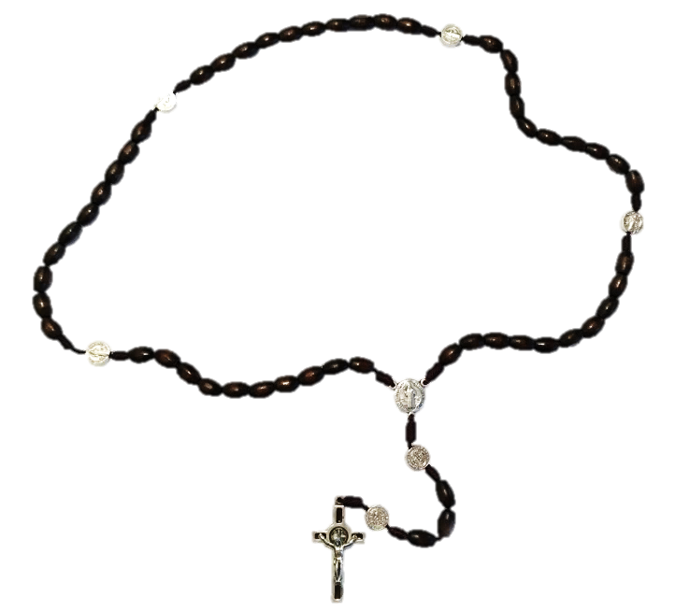

Rosary around Switzerland

Pray for Switzerland and the world
Sunday 4 October 2020 2:30 p.m.
(with Papal and Episcopal Blessings)
Name of Prayer Site: Church St. Heilige
Location: Anywhere Strasse 00, Zürich 8000
Contact Person: Heidi Müller
Handy/email: 076 622 2019 / Heidi@bluewin.ch

For much more general information about this day go to www.prayschwiiz.ch.

Join people from France, Luxembourg, Ireland, Lebanon, Syria, Jordan, Holy Land, Namibia, Zimbabwe, South Africa, India, Australia & Fuji, Philippines, New Zealand, the USA, Canada, Mexico, Panama, Bolivia, Brazil, Argentina and numerous other countries who will also pray the rosary for their countries and intensions, and for the whole world on 4/11 October 2020. See www.holyleagueofnations.com for more information.
To organize a prayer location yourself sign up at www.prayschwiiz.ch.
“The Rosary is the weapon for these times.” St. Padre Pio

